CSA1413
COMPILER DESIGN
Name: Haresh Kumar N L
Reg No: 192425009
Valid Email Addresses

Aim:
To write a LEX program to identify and print all valid email addresses from the given text file.

Algorithm:
- Start the program.
- Include the required header file and define a regular expression to match valid email addresses.
- Check whether the input file name is provided as a command-line argument.
- Open the given text file in read mode and check whether it is opened successfully.
- Assign the file pointer to yyin for lexical analysis.
- Scan the file using yylex() and identify email addresses that match the regular expression.
- Print each matched email address as a valid email.
- Ignore all other characters in the input file.
- Close the file and terminate the program.

Pseudocode:
BEGIN
Include stdio.h
Define LEX pattern for valid email addresses
IF number of command-line arguments is not 2 THEN
Print usage message
EXIT with error
END IF
Open input file in read mode
IF file opening fails THEN
Print error message
EXIT with error
END IF
Assign file pointer to yyin
CALL yylex()
Close the input file
END

Code:
%{
#include <stdio.h>
%}
%%
[A-Za-z0-9._%+-]+@[A-Za-z0-9.-]+\.[A-Za-z]{2,} {
printf("Valid Email: %s\n", yytext);
}
.|\n ;
%%
int yywrap(void)
{
return 1;
}
int main(int argc, char *argv[])
{
if (argc != 2)
{
printf("Usage: %s input.txt\n", argv[0]);
return 1;
}
FILE *fp = fopen(argv[1], "r");
if (fp == NULL)
{
printf("Error opening file!\n");
return 1;
}
yyin = fp;
yylex();
fclose(fp);
return 0;
}

Input:
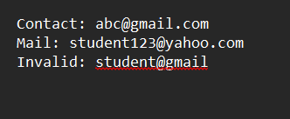
Output:
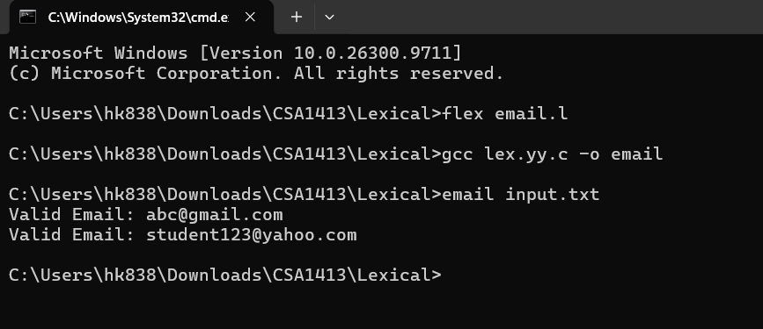

Result:
Thus, the LEX program to identify and print valid email addresses from a text file was executed successfully.

